Course Name: | iOS App Development, SwiftUI | Semester: | VII
Date of Performance: | 11 / 08 / 2026 | DIV/ Batch No: | A / A2
Student Name: | Raunak Gupta | Roll No: | 16010123250

Experiment No: 3
Title: Develop a SwiftUI application: Book Library App.

Objectives of the Experiment:
- Design and implement a real-world Book Library App application using SwiftUI to demonstrate concepts of SwiftUI Fundamentals, Layouts and Navigations, Property Wrappers @StateObject, @ObservedObject, @EnvironmentObject and @Environment.
- The application should provide an intuitive interface, modular code, and satisfy all functional requirements.

COs to be achieved:
On completion of this experiment the student will be able to:
CO1 Explain how SwiftUI’s data-flow property wrappers, @State, @Binding, @StateObject, @ObservedObject, @EnvironmentObject and @Environment, determine which view owns which piece of state.
CO2 Design a real-world Book Library application in SwiftUI with a shared observable model as the single source of truth for every screen.
CO3 Implement multi-screen navigation and interactive search, filter and sort using TabView, NavigationStack and value-based navigation destinations.
CO4 Apply reactive data flow so that changes made on one screen, such as favouriting a book or advancing a reading progress, propagate automatically to every other screen that reads the same model.
CO5 Evaluate the interface against Apple’s Human Interface Guidelines and demonstrate the effect of @Environment values such as the colour scheme, the dynamic type size and the dismiss action.
(Renumber these to match the CO list printed in your course syllabus.)

Books/ Journals/ Websites referred:
1. Apple Inc., SwiftUI Documentation, developer.apple.com/documentation/swiftui
2. Apple Inc., Managing model data in your app, developer.apple.com/documentation/swiftui/managing-model-data-in-your-app
3. Apple Inc., Human Interface Guidelines, developer.apple.com/design/human-interface-guidelines
4. Apple Inc., SF Symbols, developer.apple.com/sf-symbols/
5. Apple Inc., The Swift Programming Language, docs.swift.org/swift-book/
6. Apple Inc., Data Essentials in SwiftUI, WWDC session videos, developer.apple.com/videos/
7. Project source code for this experiment, github.com/Raunakg2005/ios-exp-3

Theory:
Basic Views, concepts and shared model
SwiftUI is Apple’s declarative user-interface framework. A view is a value type conforming to the View protocol; it does not draw pixels itself, it declares what the interface should look like for a given piece of state. When any of that state changes, the framework computes the difference and redraws the affected views. Which values are considered state, and which view owns them, is what SwiftUI’s property wrappers exist to answer.
1. @State
The starting wrapper. Marking a property with @State moves its storage out of the view struct and into a place SwiftUI manages, so that the value survives across every rebuild of the view’s body. Reading the property gets the current value; writing to it invalidates the view and schedules a redraw. Because the storage is owned by the view itself, @State is used for private, transient values, for example the text a user is typing into a search field, whether a filter sheet is presented, or a local sort order.
2. @Binding
A two-way reference to state that lives somewhere else. The parent creates the storage, usually with @State, and passes it down using the dollar-sign prefix, which projects the property as a Binding value. The child then reads and writes through that binding as if it owned the value, but a change is seen by the parent and by any sibling that reads the same source. @Binding is what lets a small reusable control, such as a toggle or a text field, mutate the caller’s state without knowing where that state actually lives.
3. ObservableObject and @Published
When state must be shared across screens, or persisted, or updated from work that is not view code, it moves out of value types altogether into a reference-type model that conforms to ObservableObject. Properties on that model that should trigger view updates are marked @Published; behind the scenes, this synthesises a Combine publisher that sends objectWillChange every time the value is written. Views that observe the model rebuild whenever that signal fires.
4. @StateObject
@StateObject creates and owns one instance of an ObservableObject and keeps it alive for the lifetime of the view or the App that declares it. It must be used exactly once per model, at the highest point in the hierarchy that needs the model. Using @StateObject elsewhere, or using @ObservedObject at the App level, would cause the model to be recreated each time the enclosing view was rebuilt, silently losing state.
5. @ObservedObject
@ObservedObject is the receiving side of the same picture. It does not create or own the model; it just declares that the current view depends on one, and receives a reference from its parent through an initialiser argument. It is the right choice when a model is created higher up and handed explicitly down one branch of the hierarchy.
6. @EnvironmentObject
When a model must be reachable by many, unrelated views, it becomes impractical to thread it through every initialiser. @EnvironmentObject lets a parent inject a model into the environment with the environmentObject modifier, and any descendant that declares an @EnvironmentObject of the same type gets a reference to that instance automatically. This is what makes reactive data flow feel effortless: the model is written in one place, and every view that reads it re-renders when it changes, without any callback plumbing.
7. @Environment
The environment carries more than user-provided objects; it also holds system-provided values that the framework fills in on every rebuild. @Environment(\.colorScheme) tells a view whether it is being drawn in light or dark mode; @Environment(\.dynamicTypeSize) reports the accessibility text scale the reader has chosen; @Environment(\.dismiss) returns a function a modally presented view can call to dismiss itself; @Environment(\.locale) reports the user’s regional settings. Reading these values automatically subscribes the view to them, so a view that draws differently in dark mode redraws for free when the reader flips the switch.
8. TabView and NavigationStack
TabView presents top-level sections that are peers, such as Home, Catalogue, Library, Profile and Settings. Each tab owns a private NavigationStack, so pushing a book detail on the Catalogue does not disturb the Library. NavigationStack, in turn, is value-driven: a NavigationLink carries a Hashable value, and navigationDestination(for:) registers the destination for that value’s type. Because the path is data, it can be inspected, appended to and cleared in code, which was not reliably possible with the older NavigationView.
9. List and search
The book catalogue is rendered as a List; the search bar and filter chips are ordinary SwiftUI views that write into pieces of state on the list screen. The list itself asks the shared model for the filtered results, so the presentation layer stays free of business logic. When a favourite is toggled from the catalogue, the model publishes the change and the same row on the Library tab, the counter on the Home dashboard and the statistics on the Profile all update at once.
10. Human Interface Guidelines
Apple’s guidelines ask for clarity, deference and depth. In practice this experiment follows them by using the system type scale and weights, declaring colours as light and dark pairs so they resolve correctly in both appearances, keeping every interactive target at least forty-four points square, confirming touches with haptic feedback through .sensoryFeedback, and using the standard tab, push and sheet presentations rather than inventing navigation of its own.
Design approach
The interface deliberately avoids the default template look of gradient headers and rounded cards. It borrows instead from print: paper, ink and a single electric lime accent, hairline rules instead of drop shadows, heavy display type for names and figures, ten-point letterspaced caps for every label, and monospace for anything that reads as data. The accent is used for exactly one thing per screen, so it always means "look here", such as the reader’s current book on the dashboard or the active filter chip on the catalogue.
The application is organised as a small design system of palette, typography, shared components and custom shapes, with the feature screens composed from it, so that a change to a colour or a panel style propagates across every screen at once. The same design system is carried over from Experiment 1 and Experiment 2.

Problem statement/ Tasks

Develop a Book Library application using SwiftUI that allows users to browse books, view book details, search and filter books, maintain favorites and reading lists, and manage reading preferences. Use @EnvironmentObject to share library data across multiple views and use @Environment to access system-provided values such as color scheme, locale, Dynamic Type, and dismiss. Demonstrate that changes made in one view are automatically reflected in other views through SwiftUI's reactive data-flow mechanism.

UI Screens
• Home / Dashboard
• Book Catalogue/ ListView
• Book Description/ DetailView
• Student ProfileView
• Settings
Data Flow:
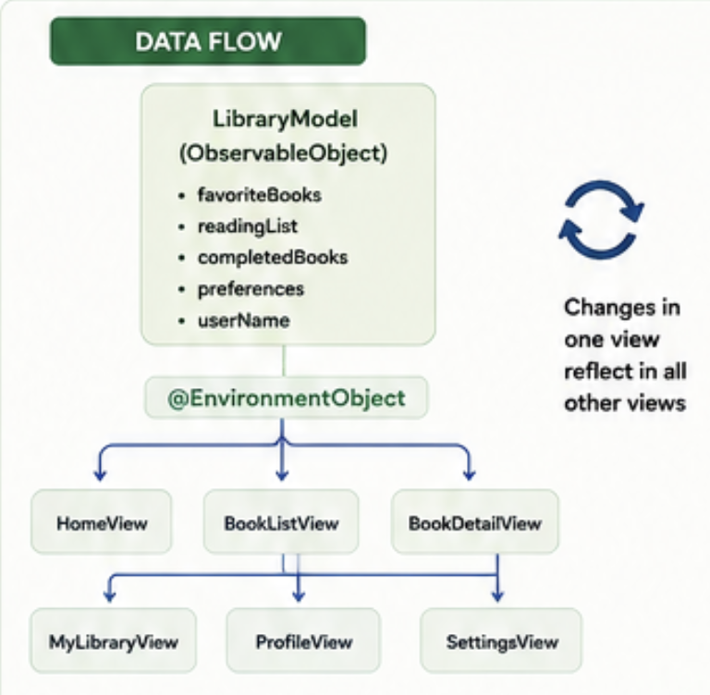

Code :
The application was built inside the exp 3 Xcode project supplied for this laboratory. It is written entirely in SwiftUI with no third-party dependencies, and is organised as a small design system of palette, typography, shared components and custom shapes from which the feature screens are composed.
The target uses a file-system synchronized group, so each of the source files listed below is compiled automatically without any project configuration. The complete source listing is maintained in the project repository at github.com/Raunakg2005/ios-exp-3
Source files
exp_3App.swift
Application entry point. Declares the App conformance and creates the single LibraryModel with @StateObject, injecting it into the environment with .environmentObject().
Design / Palette.swift
Paper, ink and lime colour set, each defined as a light and dark pair.
Design / Typography.swift
The three type voices: display, micro-label and monospace, and the custom view modifiers that apply them.
Design / Components.swift
Shared furniture: block modifier, hairline rule, tag, search field, empty note, initials plate and the numbered tab header.
Design / Shapes.swift
Custom Shape types and the small data displays built from them, including the wave lines used on the inverted plates and the tick meter used on progress bars.
Model / Book.swift
Value type for a book, with a genre enumeration, a rating value and a deterministic cover seed used to draw a unique cover for each ISBN. Also the Preferences struct with an appearance and a text-scale setting.
Model / LibraryModel.swift
The single source of truth. An ObservableObject with @Published properties for the user name, the favourites, the reading list, the completed books and the preferences. Every mutation and every derived collection lives on this type, so the views stay a presentation layer.
Model / LibraryData.swift
Fourteen real books with genuine ISBNs. This is the only file to edit to change the catalogue.
Features / RootView.swift
The TabView with five top-level tabs, plus the shared page chrome and the application of the reader’s appearance and text-scale preferences.
Features / HomeView.swift
Dashboard: masthead, notice ticker, currently-reading card, shelves and four shortcut tiles that jump to the other tabs.
Features / BookListView.swift
Catalogue: search field, genre rail, sort row and the list of books returned by the model’s search function.
Features / BookDetailView.swift
The detail screen pushed from a book row. Reads and writes the model to toggle a favourite, add to the reading list and record progress.
Features / MyLibraryView.swift
The reader’s shelves: currently reading, reading list, favourites and completed books, in one place.
Features / ProfileView.swift
A profile screen with the reader’s totals, monthly goal progress and a genre breakdown of the books they have finished.
Features / SettingsView.swift
The environment demonstration. Changes to appearance and text scale are written into the model and read on RootView, so every screen re-renders.
Features / BookCoverView.swift
A drawn cover generated from the book’s ISBN, cycling through six layouts. The application ships with no image assets.
Features / TickerView.swift
The endlessly scrolling marquee, carried over from earlier experiments.

Output:
The application was built and run on the iOS 26.2 simulator (iPhone 17 Pro) using Xcode 26.2. Screenshots of the running app are inserted below.
Insert screenshots here: Home dashboard, Catalogue list, Book detail, My Library, Profile and Settings. Six figures in total.
The interactive verification of the environment-object idea is to favourite a book on the Catalogue, then switch to My Library and to the Home dashboard: the count on the dashboard and the favourites row on the library update at the same moment, without any callback or notification code, because both views read the same @Published property on the shared LibraryModel.

Post Lab Subjective/Objective type Questions:
The questions below were answered as part of the post-laboratory work.
1. What is an ObservableObject, and why must the model in this experiment be one?
Ans. ObservableObject is a Combine protocol adopted by reference-type models that publish changes. A conforming class exposes an objectWillChange publisher that fires whenever a @Published property is about to be written. Views observing such a model, through @StateObject, @ObservedObject or @EnvironmentObject, subscribe to that publisher and redraw. The library model must be one because the reader’s favourites, reading list, completed set and preferences are shared across five screens and must survive across every view rebuild.
2. Distinguish @StateObject from @ObservedObject.
Ans. @StateObject creates and owns one instance of an ObservableObject and keeps it alive for the lifetime of the enclosing view or App. @ObservedObject is the receiving side: it does not create or own the model, it just declares a dependency on one that was created elsewhere and handed in. Using @ObservedObject at the top of the hierarchy is a well-known bug, because the parent may rebuild and a fresh model would be instantiated on each rebuild, silently losing state.
3. What does @EnvironmentObject do that ObservedObject does not?
Ans. @EnvironmentObject reads a model out of the environment instead of receiving it through an initialiser argument. A parent injects the model with .environmentObject(model), and any descendant, at any depth, that declares an @EnvironmentObject of that type gets a reference to the same instance. This is the right choice for a truly shared model, such as the library in this application, because it avoids threading the same argument through every screen in between.
4. What is @Environment for, and give three concrete uses in this experiment.
Ans. @Environment reads system-provided values that the framework fills in on every rebuild. The application uses @Environment(\.colorScheme) through preferredColorScheme so the appearance chosen in Settings applies to every screen, @Environment(\.dynamicTypeSize) so the text scale chosen in Settings applies to every screen, and @Environment(\.dismiss) so pushed detail screens can dismiss themselves from their own toolbar button. Reading these values automatically subscribes the view to them.
5. How does a @Published property drive a redraw?
Ans. The @Published wrapper synthesises a Combine publisher on the enclosing ObservableObject and sends objectWillChange each time the value is written. Views that observe the object subscribe to that publisher; when they receive the signal they invalidate their bodies and SwiftUI schedules a redraw, computing the diff between the old and the new view tree and applying it.
6. What is a Binding, and how does it differ from @State?
Ans. @State declares storage the view itself owns, and is normally private. A Binding is a read-write reference to state owned elsewhere, projected from another wrapper with the dollar-sign prefix. Passing $someState into a child view creates a Binding the child can read and write; the change is seen by the parent and by any sibling that reads the same value. In the enquiry form on the Settings tab, TextField and Picker take bindings so they can write back into the model without owning any state themselves.
7. What was the layout gotcha you resolved on the earlier experiment, and why does the same guard appear in this app?
Ans. The scrolling ticker on the dashboard is an HStack roughly two thousand points wide. Placed directly in the layout, its intrinsic width would propagate up through the surrounding VStack and the ScrollView, stretching the whole scroll view to about ten screens across and centring every sibling off the display. The ticker is therefore placed in an .overlay on a flexible Color.clear, which never contributes to its host’s size, and every page is clamped with containerRelativeFrame(.horizontal) as a backstop.
8. How does NavigationStack differ from NavigationView, and how are pushes made in this application?
Ans. NavigationStack, introduced in iOS 16 to replace NavigationView, models the screen stack as data. A NavigationLink carrying a Hashable value pushes whichever destination is registered by navigationDestination(for:). Because the path is an ordinary collection it can be inspected, appended to and cleared programmatically. In this application every push is by value: NavigationLink(value: book) pushes BookDetailView(book:).
9. Explain how favouriting a book on the Catalogue updates the counter on the Home dashboard.
Ans. Both screens depend on the same LibraryModel through @EnvironmentObject. The heart button on a Catalogue row calls library.toggleFavourite(book), which mutates the favouriteIDs set, marked @Published. The wrapper sends objectWillChange; every subscribed view invalidates its body. The dashboard counter, which reads library.favoriteBooks.count, and the favourites shelf on the Library screen, which reads library.favoriteBooks directly, both rebuild in the same tick.
10. What is a Hashable value in the context of NavigationStack, and why is the Book type made Hashable in this application?
Ans. A NavigationStack path can hold values of any Hashable type; navigationDestination(for:) is keyed by the type. Book is declared Hashable so it can be used as the value carried by a NavigationLink and as the argument of navigationDestination(for: Book.self), which turns the row tap into a straightforward, value-driven push without a per-destination Boolean flag on the source view.
11. Why does the app persist state in UserDefaults through the model, and not from the views directly?
Ans. The views observe the model; if they wrote to UserDefaults on their own they would duplicate work and, worse, could disagree with the model on what the current value is. Putting persistence in the model’s property observers means every write goes through one path: the model is updated, @Published fires, views rebuild and UserDefaults is refreshed, all in one place.

Conclusion:
This experiment implemented a real-world Book Library application in SwiftUI, and every property wrapper the brief names was exercised in a real screen rather than in isolation. LibraryModel is created once as a @StateObject on the App and injected into the environment; every one of the five tabs reads it with @EnvironmentObject; screen-local values such as the search text, the selected genre and the sort order are held as @State and passed to reusable controls as bindings. System-provided values are read with @Environment, so the appearance and text-scale settings chosen on the Settings tab take effect for every screen at once.
The clearest lesson from the exercise was the difference between the creator side and the reader side of an ObservableObject. Using @ObservedObject at the App level would recreate the model on every App rebuild and silently lose the reader’s favourites and reading list; using @StateObject on a deep child would create a new model each time that child appeared. The one @StateObject at the App, and @EnvironmentObject everywhere else, is the pattern that keeps the reactive data flow single-sourced and predictable.
The environment demonstration also made the reactive picture concrete: a change made on the Settings screen is not communicated to the other tabs by any explicit callback. Both sides read the same environment value, and both sides are invalidated by SwiftUI when that value changes.

